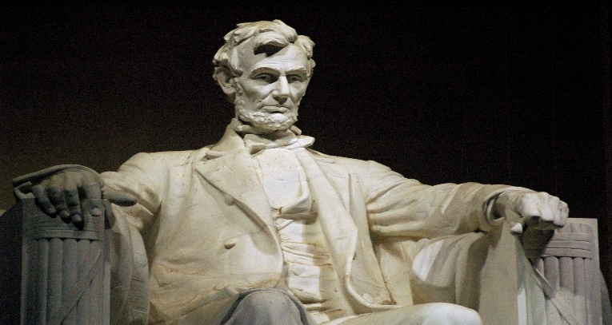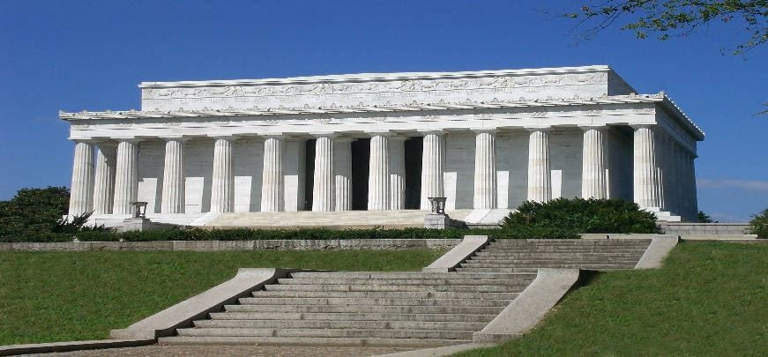 **Monument of Abraham Lincoln**  **Abraham Lincoln**

**Lincoln Memorial**, stately monument in [Washington, D.C.](https://www.britannica.com/place/Washington-DC), honouring [Abraham Lincoln](https://www.britannica.com/biography/Abraham-Lincoln), the 16th president of the [United States](https://www.britannica.com/place/United-States), and “the virtues of [tolerance](https://www.britannica.com/dictionary/tolerance), honesty, and constancy in the human spirit.” Designed by [Henry Bacon](https://www.britannica.com/biography/Henry-Bacon) on a plan similar to that of the [Parthenon](https://www.britannica.com/topic/Parthenon) in Athens, the structure was constructed on reclaimed marshland along the banks of the [Potomac River](https://www.britannica.com/place/Potomac-River). The site selection caused controversy; the speaker of the House of Representatives, Joseph Cannon, favoured a more prominent spot across the Potomac, maintaining: “I’ll never let a memorial to Abraham Lincoln be erected in that g– damned swamp.” The cornerstone was set in 1915, and the completed memorial was dedicated before more than 50,000 people on May 30, 1922. Lincoln’s only surviving son, [Robert Todd Lincoln](https://www.britannica.com/biography/Robert-Todd-Lincoln), attended the ceremony. President [Warren G. Harding](https://www.britannica.com/biography/Warren-G-Harding) and Chief [Justice](https://www.merriam-webster.com/dictionary/Justice) of the Supreme Court [William Howard Taft](https://www.britannica.com/biography/William-Howard-Taft), a former president, delivered addresses. Ironically, despite Lincoln’s renown as the “Great Emancipator,” the dedication ceremonies were strictly segregated; even Robert Moton, president of [Tuskegee Institute](https://www.britannica.com/topic/Tuskegee-University), who spoke in the ceremony, was not allowed to sit on the speaker’s platform and instead was required to sit in an area reserved for [African Americans](https://www.britannica.com/topic/African-American).

The Lincoln Memorial includes 36 columns of Colorado marble, one for each state in the Union at the time of Lincoln’s death in 1865; each column stands 44 feet (13.4 metres) high. The names of the 48 [contiguous](https://www.merriam-webster.com/dictionary/contiguous) states are listed above the [colonnade](https://www.britannica.com/technology/colonnade-architecture), and the dates of their admission to the Union are engraved in Roman numerals. Because Hawaii and Alaska attained statehood several decades after the Lincoln Memorial was finished, their names are inscribed on a plaque located on the front steps.

The interior features a 19-foot (5.8-metre) seated statue of Lincoln made of Georgia white marble. It was assembled on the [premises](https://www.merriam-webster.com/dictionary/premises) from 28 pieces and rests on a pedestal of Tennessee marble. The statue was designed by [Daniel Chester French](https://www.britannica.com/biography/Daniel-Chester-French) and carved by the Piccirilli brothers of [New York](https://www.britannica.com/place/New-York-state). Inscribed on the south wall of the monument is Lincoln’s [Gettysburg Address](https://www.britannica.com/event/Gettysburg-Address), on the north wall his Second Inaugural Address. On the ceiling are two paintings by [Jules Guerin](https://www.britannica.com/biography/Jules-Guerin), Reunion and Progress and Emancipation of a Race. On a direct east-west axis with the [Washington Monument](https://www.britannica.com/topic/Washington-Monument-Washington-DC) and the [United States Capitol](https://www.britannica.com/topic/United-States-Capitol), the Lincoln Memorial serves as the terminus to the western end of [the Mall](https://www.britannica.com/topic/the-Mall). It is situated on the Reflecting Pool near the [Vietnam Veterans Memorial](https://www.britannica.com/topic/Vietnam-Veterans-Memorial) and the [Korean War Veterans Memorial](https://www.britannica.com/topic/Korean-War-Veterans-Memorial).